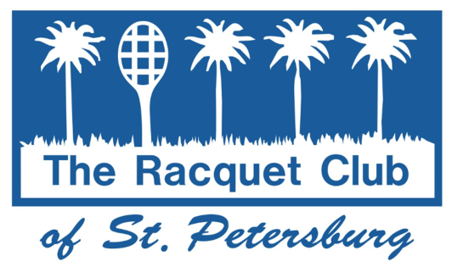
SUMMER JUNIOR TENNIS 2024 CAMP

Join us for weekly camp sessions with development of tennis skills, drills, match play and games on court. Our goal is to make learning and improving tennis FUN! Campers will be on the court from 9-11:30 am, followed by lunch [provided], swimming pool activities and more tennis. Please bring a swimsuit and sunscreen. Camp Time: 9:00 AM-2:00 PM.

AGES: BOYS AND GIRLS 5 - 16
LEVEL: BEGINNER / INTERMEDIATE/ADVANCED
DATES: 13 WEEKS; STARTING MAY 28
COST: MEMBERS - $225 PER WEEK
NON-MEMBERS - $240 PER WEEK

To sign up please fill in the registration blank on the reverse side and drop it off in the Pro Shop, or mail it to:

RACQUET CLUB OF ST. PETERSBURG
ATTN: SUMMER CAMP

170, 47TH AVENUE NE

ST. PETERSBURG, FLORIDA 33703

(727) 527-6553

The Summer Junior Tennis Camps are a small part of our overall Junior Development Program. We offer group instruction for beginners to
competitive players throughout the year.

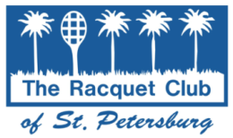

SUMMER JUNIOR TENNIS CAMPS
REGISTRATION FORM 2024

NAME _____________________________________ AGE _____________

ADDRESS ___________________________________________________

Email: _________________________________ PHONE # ____________

Week 1 May 28 May 31 ____ 4 day week
WEEK 2 June 3 - June 7 ____
WEEK 3 June 10 - June 14 ____
WEEK 4 June 17 – June 21 ____

WEEK 5 June 24 – June 28 ____
WEEK 6 July 1,2,3 July 5 ____ 4 day week
WEEK 7 July 8 – July 12 ____
WEEK 8 July 15 – July 19 ____
WEEK 9 July 22 – July 26 ____

WEEK 10 July 29 – August 2 ____

WEEK 11 August 5 – August 9 __ _

WEEK 12 August 12 –August 16 ____

WEEK 13 August 19 –August 23 ____

No camp on Monday, May 27 and Thursday, July 4 (4 day weeks)

Cancellations: Choose another week or refunds no later than Aug.12.

RACQUET CLUB MEMBER # ____________$225/WK Daily Rate: $55

NON MEMBER _________$240/Wk Daily Rate: $60

CASH ____ CHECK ____

ABLE TO SWIM? Yes No (please circle)
FOOD ALLERGIES? Yes No (please circle). If yes, please list:

GENERAL RELEASE OF LIABILITY:
We hereby release for and on behalf of ourselves, and our minor child, Racquet Club of St. Petersburg, all owners and employees of the above establishments, from any and all damages and/or personal injury that may occur in and from any connection with a Racquet Club of St. Petersburg sponsored event. We the undersigned have read this release and understand all its terms and hereby executor it voluntarily with all knowledge and understanding of its significance. Parents and/or all Guardians are responsible for showing ID and signing In/Out Form on Desk.

MEDICAL RELEASE:
We hereby also consent to emergency or hospital services that may be rendered by an accredited hospital, or by an appointed physician or physicians, in the event such need arises in the opinion of a duly licensed physician.

Signature of Parent or Guardian Date

