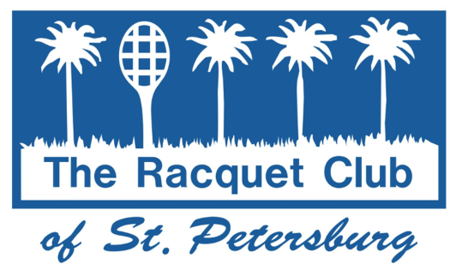
SUMMER JUNIOR TENNIS 2022 CAMP

Join us for weekly camp sessions with development of tennis skills, drills, match play and games on court. Our goal is to make learning and improving tennis FUN! Campers will be on the court from 9-11:30 am, followed by lunch [provided], swimming pool activities and more tennis. Please bring a swimsuit and sunscreen. Camp Time: 9:00 AM-2:00 PM.

AGES: BOYS AND GIRLS 5 - 16
LEVEL: BEGINNER / INTERMEDIATE/ADVANCED
DATES: 12 WEEKS; STARTING June 1
COST: MEMBERS - $205 PER WEEK
NON-MEMBERS - $230 PER WEEK

To sign up please fill in the registration blank on the reverse side and drop it off in the Pro Shop, or mail it to:

RACQUET CLUB OF ST. PETERSBURG
ATTN: SUMMER CAMP

170, 47TH AVENUE NE

ST. PETERSBURG, FLORIDA 33703

(727) 527-6553

The Summer Junior Tennis Camps are a small part of our overall Junior Development Program. We offer group instruction for beginners to
competitive players throughout the year.

SUMMER JUNIOR TENNIS CAMPS
REGISTRATION FORM 2022

NAME _____________________________________ AGE _____________

ADDRESS ___________________________________________________

Email: _________________________________ PHONE # ____________

WEEK 1 May 31 – JUNE 3 ____ (4 day/wK )
WEEK 2 June 6 - June 10 ____
WEEK 3 June 13 – June 17 ____

WEEK 4 June 20 – June 24 ____
WEEK 5 June 27 – July 1 ____
WEEK 6 July 4 – July 8 ____
WEEK 7 July 11 – July 15 ____
WEEK 8 July 18 – July 22 ____
WEEK 9 July 25 – July 29 ____

WEEK 10 August 1 – August 5 ____

WEEK 11 August 8 – August 12 ____

WEEK 12 August 15 – August 19 ____

RACQUET CLUB MEMBER # ____________$205

NON MEMBER _________$230

CASH ____ CHECK ____

ABLE TO SWIM? Yes No (please circle)
FOOD ALLERGIES? Yes No (please circle). If yes, please list:

GENERAL RELEASE OF LIABILITY:
We hereby release for and on behalf of ourselves, and our minor child, Racquet Club of St. Petersburg, all owners and employees of the above establishments, from any and all damages and/or personal injury that may occur in and from any connection with a Racquet Club of St. Petersburg sponsored event. We the undersigned have read this release and understand all its terms and hereby executor it voluntarily with all knowledge and understanding of its significance. Parents and/or all Guardians are responsible for showing ID and signing In/Out Form on Desk.

MEDICAL RELEASE:
We hereby also consent to emergency or hospital services that may be rendered by an accredited hospital, or by an appointed physician or physicians, in the event such need arises in the opinion of a duly licensed physician.

Signature of Parent or Guardian Date

